# MARKS 10

**Question 1**

Write a program of Balancing Brackets, use a suitable data structure to print whether the string entered is a Balanced Brackets or Unbalanced String

# Sample input

( [ [ { } ] ] )

# Sample Output

The entered String has Balanced Brackets

# Sample Input

( [ [ { } ] ] ) )

# Sample Output

The entered Strings do not contain Balanced Brackets

-

# MARKS 10

**Question 2)** Print the longest path from the root to the leaf in a binary tree.

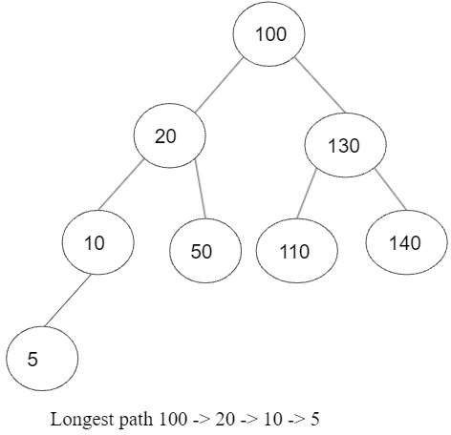

# Instructions

1. You can declare class Node, in the same class as driver class
2. You can write programming logic/functions in one class itself.
3. You can hardcode the inputs.